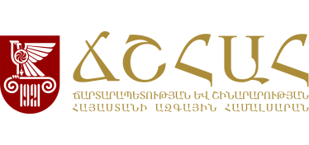

AGENDA
of NUACA Erasmus+ Projects Info Day
28 February, 2022
Scientific Council Hall of NUACA (Room # 2339)

Time | Activity | Speaker
12:00-12:10 | Introduction word: of «Erasmus+ projects significance for the education service provided by the NUACA» | Mr. Vardkes Edoyan, Vice Rector of International communication affairs
12:10-12:30 | “Developing Interdisciplinary Postgraduate Programmes and Strengthening Research Networks in Geoinformation Technologies in Armenia and Kyrgyzstan” (GeoTAK) project (2021-2023) | Mr. Varazdat Hovhannisyan, Head of Education Quality Assurance and Development Center
12:30-12:35 | Q & A
12:35-12:55 | "Development of a flexible, innovative and practical framework for Work-based Learning in higher education of Armenia and Russia" (FlexWBL) (2020-2022) | Ms. Irina Vanyan, Head of Strategic Planning and quality assurance department
12:55-13:00 | Q & A
13:00-13:20 | “Capacity Building in Sustainability for Architectural Heritage” (SAH) (2021-2023) | Ms. Emma Harutyunyan, Chair Head,  Ms.Irina Vanyan
13:20-13:25 | Q & A
13:25-13:45 | “Transforming Architectural and Civil Engineering Education towards a Sustainable Model” (TACEESM) (2021-2023) | Mr. Armen Shatvoryan, Dean of Architecture Faculty  Ms. Irina Vanyan
13:45-13:50 | Q & A
13:50-14:10 | “Promoting Academia-Industry Alliances for R&D through Collaborative and Open Innovation Platform” (All4R&D) (2018-2022) | Ms. Gohar Avetisyan
14:10-14:15 | Q & A
14:15-14:25 | Closing word | Mr. Vardkes Edoyan,  Mr. Varazdat Hovhannisyan

